Artists in Residency Program - Regular

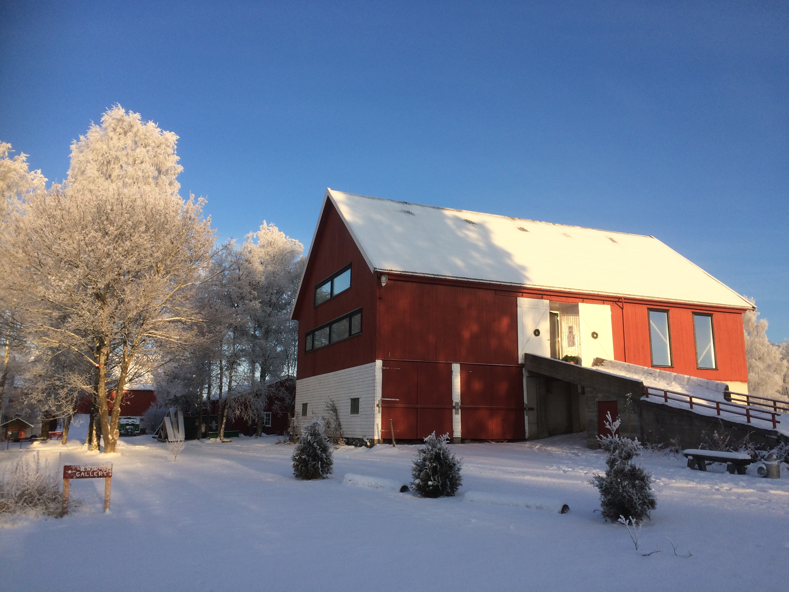

We accept applications for the Regular Residency (from September, 1st to May 31st) all year around.
The price of the Regular Residency includes housing and use of the heated studio (sprung dance floor measuring 19x12 meters, 8,5 meters height) and the facilities can be booked long time in advance.
NB. You will need to arrange your own transportation (a car is recommended).

Please submit the form in English or Norwegian to: red.residency.danz@gmail.com

Applicant
Group: ……………………………………………........................................................................................................................
Artistic director: ...................................................................................……………….....................……..........................
Address: ………………………………………………………………………..........................................................................................
Postcode/City: ........................................................... Country: ...............................................................................
Contact person: ........................................................................................................................................................
E-Mail:.......................................................................... Mobile:................................................................................

Project description
Title: ........................................................................................................................................................................
Genre (artistic field): .................................................. Number of participants: …....................................................

Dates of residency–binding

Date: Signature:

For the statistic, how did you get to know about the residency?

Additional requirements:
Some of the extra facilities requires additional price.

O free access to the wood
O free access to the field (season regulated)
O gallery (3 small exhibition/installation rooms)
O multiple screening rooms
O café theatre with 3,5x3,5 meter stage
O small space available for carpentry
O Theater lights
O artistic consultancy*

* The two first hours of artistic consultancy is included.

(The details on this page are for us to understand the size of the project and your potential demand. Please contact us if there are any major changes.)

Date: Signature:

